ANED 2014 Task 5 – European semester country fiche on disability

Country: Ireland

Author(s): Jenni Kline
With comparative data provided by the ANED core team

The Academic Network of European Disability experts (ANED) was established by the European Commission in 2008 to provide scientific support and advice for its disability policy Unit. In particular, the activities of the Network will support the future development of the EU Disability Action Plan and practical implementation of the United Nations Convention on the Rights of Disabled People.

This country report has been prepared as input for the Flash synthesis report on the European Semester.

Summary of the overall situation and challenges

Ireland exited the EU-IMF financial support programme on the 15th of December 2013. (see ANED 2013 Task 5-IE for a more detailed description of Ireland’s participation in the EU-IMF financial support programme). The years under the IMF saw many cuts to disability specific services and general services that people with disabilities use and depend on. As stated by the Disability Federation of Ireland “Since 2008, there has been a steady erosion of the kinds of flexible supports that facilitate choice, autonomy and independent living for people with disabilities.”

Despite the long term erosion of disability supports Budget 2015 contains few positive changes for people with disabilities in Ireland. The recently submitted budget for 2015 is the first non-austerity Budget for Ireland in seven years. The budget includes a 25% Christmas bonus to people in receipt of the Blind Pension and Disability Allowance but no overall increases to the disability allowance. There are also no measures that address the long documented extra costs of disability despite calls for such measures from disability organizations. Although this most recent budget does not contain cuts to disability services it does very little to begin to rebuild services and create a system that enables all people with disabilities in Ireland to reach their full potential.

Overall there is very little national data on people with disabilities in Ireland; the last national survey on people with disabilities was in 2006 conducted by the Central Statistic Office in Ireland. Without such targeted data collection policy makers cannot be made aware of disparities of access between people with and without disabilities and policies cannot be designed that address those disparities.

Furthermore Ireland has still yet to ratify the CRPD as it is still waiting to pass new legal capacity legislation, which would make the laws of Ireland more in line with CRPD.

Assessment of the situation of disabled people with respect to the Europe 2020 headline targets

Strategic targets

Table 1: Europe 2020 and agreed national targets for the general population
 | Europe 2020 targets | National targets
Employment | 75% of the 20-64 year-olds to be employed | 69-71%
Education | Reducing the rates of early school leaving below 10% | 8%
Education | At least 40% of 30-34–year-olds completing third level education | 60%
Fighting poverty and social exclusion | At least 20 million fewer people in or at risk of poverty and social exclusion | 200,000 (persons in combined poverty)

Any relevant disability targets from national strategies or sources:
Employment
The National Disability Strategy Implementation Plan 2013-2015 has set and achieved a minimum target of 3% of employees in public sector are people with disabilities.

Higher Education
The Higher Education Authority in in the process of developing a New National Plan for Equity of Access to Higher Education, 2014-2017 and published Consultation Paper: Towards the development of a New National Plan for Equity of Access to Higher Education in August, 2014. The consultation paper sets a target of 8% for percentage of all new entrants to higher education with a disability. The target focuses on people with physical, sensory and multiple disabilities. The National Disability Strategy Implementation Plan has a High Level Goal that calls for “People with disabilities get the education and training that enables them to reach their potential.”

A note on the use of EU data
Unless specified, the summary statistics presented in this report are drawn from 2012 EU-SILC micro data. The EU-SILC sample includes people living in private households and does not include people living in institutions. The proxy used to identify people with disabilities (impairments) is whether ‘for at least the past 6 months’ the respondent reports that they have been ‘limited because of a health problem in activities people usually do’. Responses to this question vary between countries and national data sources are added for comparison, where available.

Table 2: Self-reported ‘activity limitations’ as a proxy for impairment/disability (EU-SILC 2012)
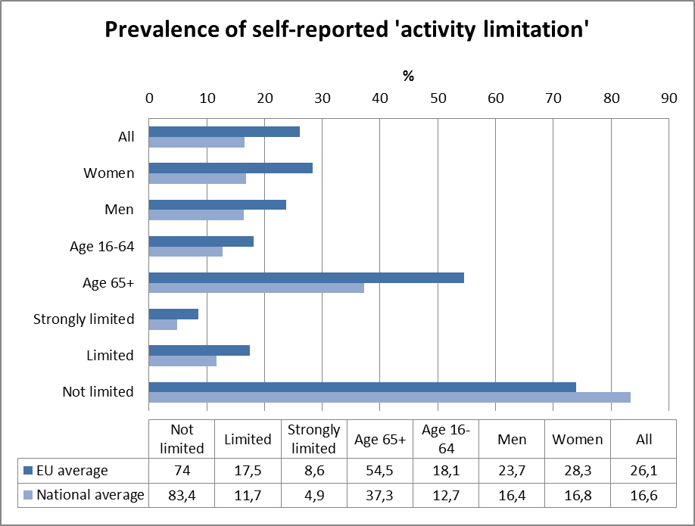
Source: EUSILC UDB 2012 – version 2 of August 2014

In subsequent tables, these data are used to estimate outcomes for ‘disabled’ people in the main target areas for EU2020 – employment, education and poverty risk. Due to the small number of observations for young people (aged 16-24) caution should be attached to interpreting results for this age group.

Employment data

Table 3: Most recent employment data, aged 20-64
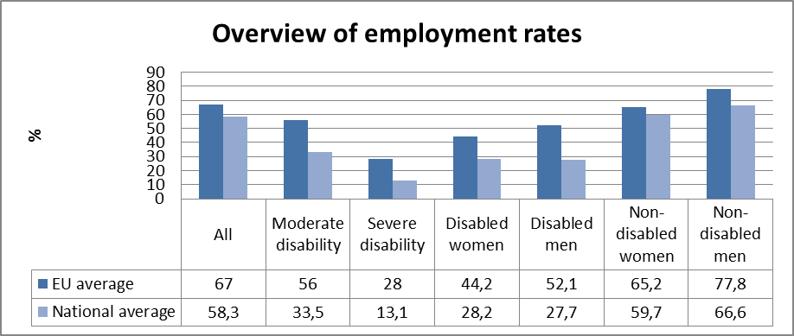

Table 4: Employment rate data, by age group
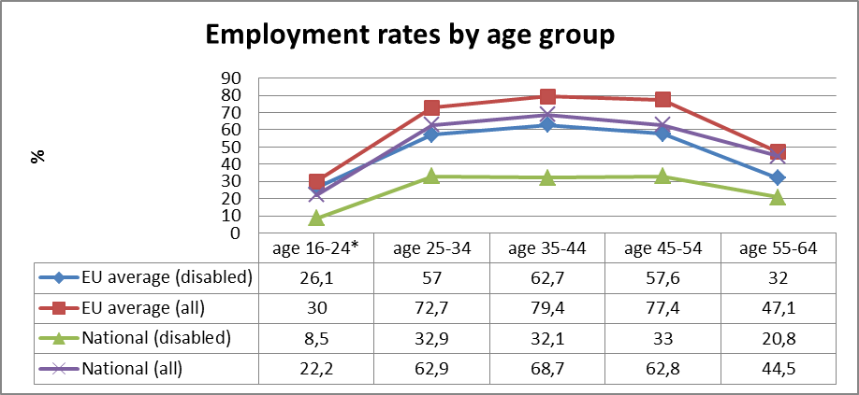
Table 5: comparison of data from EU-SILC (2012) and the LFS ad hoc disability module (2011)
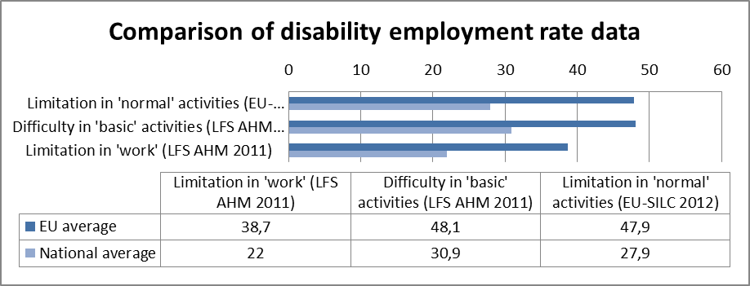
Source: EUSILC UDB 2012 – version 2 of August 2014, and Eurostat LFS AHM 2011

Table 6: Five-year trends in employment by gender and disability (aged 20-64)
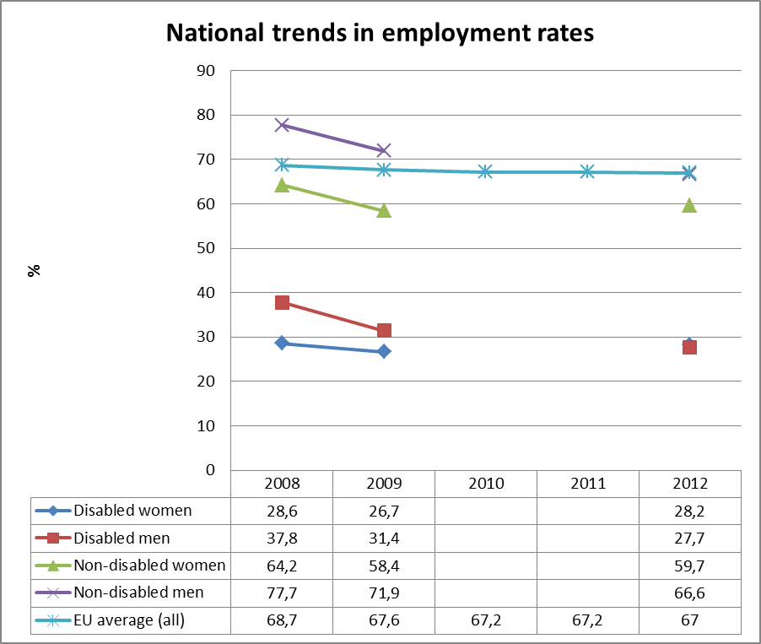
Source: EUSILC UDB 2012 – version 2 of August 2014 (and preceding UDBs)

There is some missing data for Ireland in the EU-SILC series.

Alternative data on disability and employment from national sources:
3% of employees in the public sector are people with disabilities. Additionally the National Physical and Sensory Disability Database 2013 report states that only 10% of their members participate in open employment. The National Intellectual Disability Database (NIDD) 2013 report states that only 308 of those over 18 and registered with NIDD receive open employment services.

Unemployment

National administrative rules and definitions of ‘unemployment’ may affect the way in which people with disabilities are categorised in different countries.

Table 7: Most recent unemployment data, aged 20-64
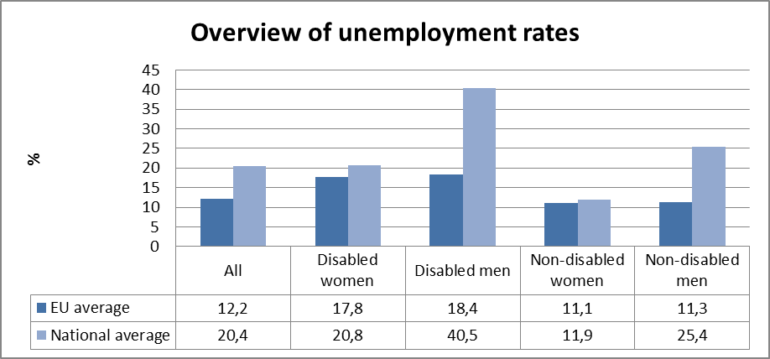
Source: EUSILC UDB 2012 – version 2 of August 2014
Table 8: Unemployment rate data, by age group
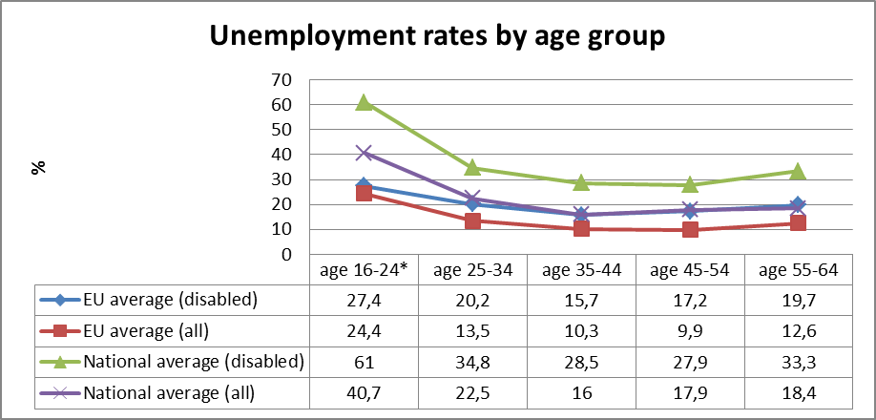
Source: EUSILC UDB 2012 – version 2 of August 2014

Alternative data on disability and unemployment from national sources:
A study on people with spinal injuries in Ireland released in 2014 found that only 13% of their members were able to maintain their full time employment after their spinal chord injury. The National Physical and Sensory Disability Database found that 39.2% of respondents experienced a participation restriction in employment or job seeking. Unfortunately the National Intellectual Disability Database does not keep the same data.

Economic activity

Table 9: Most recent economic activty data, aged 20-64
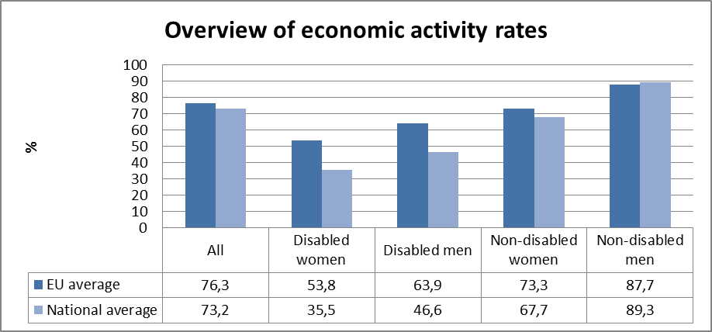
Source: EUSILC UDB 2012 – version 2 of August 2014

Table 10: Activity rate data, by age group
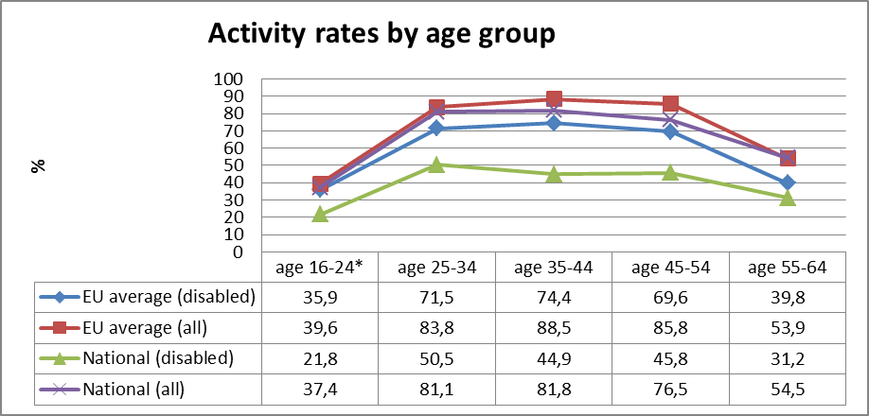
Source: EUSILC UDB 2012 – version 2 of August 2014

Alternative data on disability and economic activity from national sources:
There was no alternative data available on disability and economic activity from national sources for the time period requested.

Education data

EU statistical comparisons are more limited concerning the education of young women and men with disabilities in the EU2020 target age groups. Data is available from EU-SILC (annually) as well as the Eurostat Labour Force Survey ad-hoc disability module (for 2011), but with low reliability for several countries on the key measures. Using wider age range can improve reliability but estimations by gender remain indicative. EU trends are evident but administrative data may offer more reliable alternatives to identify national trends, where available.

Early school leavers

The EU-SILC sample for the target age group (aged 18-24) includes the following number of people reporting activity ‘limitation’ (as a proxy for impairment/disability).

Table 11: EU-SILC sample size in the target age group 18-24
 | No activity ‘limitation’ | Activity ‘limitation’ | Women reporting ‘limitation’ | Men reporting ‘limitation’
EU sample | 37,438 | 2,693 | 1,338 | 1,355
National sample | 743 | 40 | 19 | 21
Source: EUSILC UDB 2012 – version 2 of August 2014

Table 12: Early school leavers aged 18-24 (indicative based on above sample size)
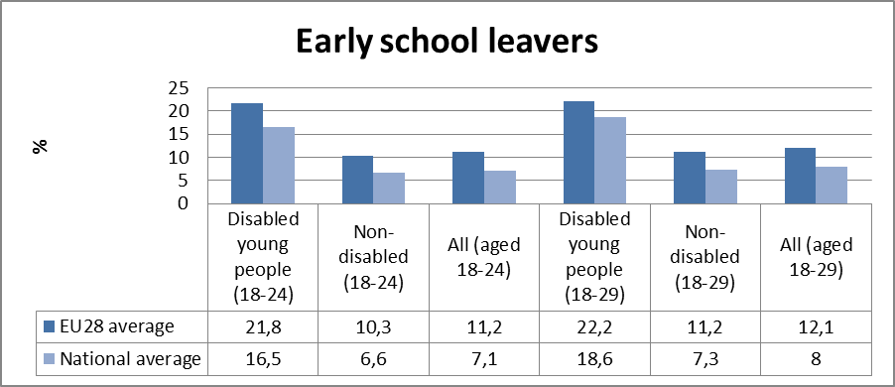

Alternative data on disability and early school leavers from national sources:
In 2012 there was a reduction in budget that impacted school leavers with intellectual disabilities. In 2012, 695 school leavers were left without placements. There was another shortage of day places and training programmes for school leavers with a disability again in 2013 with 850 school leavers with disabilities needing services.

Tertiary education

The EU-SILC sample for the target age group (aged 30-34) includes the following number of people reporting activity ‘limitation’ (a proxy for impairment/disability).

Table 13: EU-SILC sample size for the target age group 30-34
 | No activity ‘limitation’ | Activity ‘limitation’
EU sample | 25,596 | 2,801
National sample | 749 | 77

Table 14: Completion of tertiary or equivalent education (indicative based on above sample)
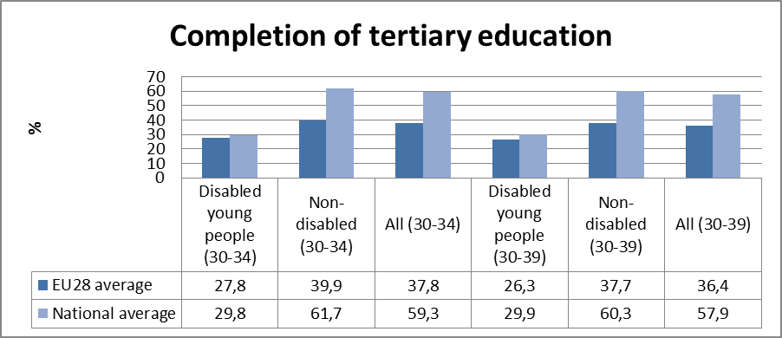
Source: EUSILC UDB 2012 – version 2 of August 2014

Alternative data on disability and tertiary education from national sources:
6.4% of new entrants to undergraduate education in 2012/2013 self identified as students with a disability.

In addition in a survey by AHEAD 26 Higher Education Institutions in Ireland identified a total of 9082 students as students with disabilities, which represents only 4.6 % of the total student population.

Poverty and social exclusion data

EU SILC data provides indicators of the key risks for people with disabilities. In addition to household risks of low work intensity, there are risks of low income (after social transfers), and material deprivation. These three measures are combined in the overall estimate of risk. The risks for older people do not include work intensity (Eurostat refers to the age group 0-59 for this measure). The survey does not distinguish ‘activity limitation’ (the proxy for impairment/disability) for children under the age of 16. Relevant data from national sources is added where available.

Table 15: People living in household poverty and exclusion by key risk (aged 16-59)
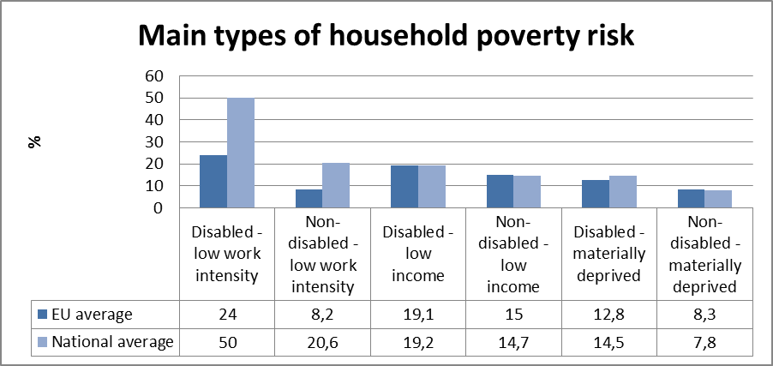
Source: EUSILC UDB 2012 – version 2 of August 2014

Table 16: People living in household poverty and exclusion by gender and severity (aged 16+)
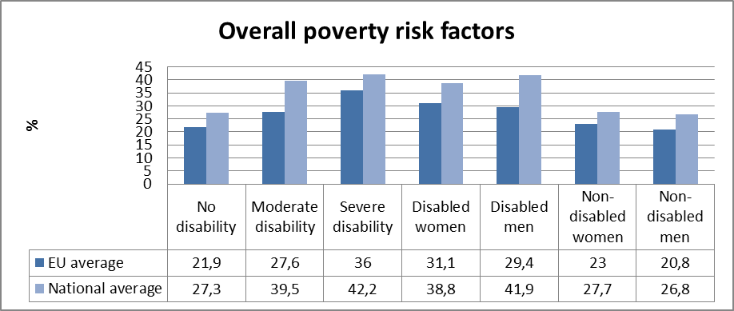
Table 17: Overall risk of household poverty by main age group (all, aged 16+)
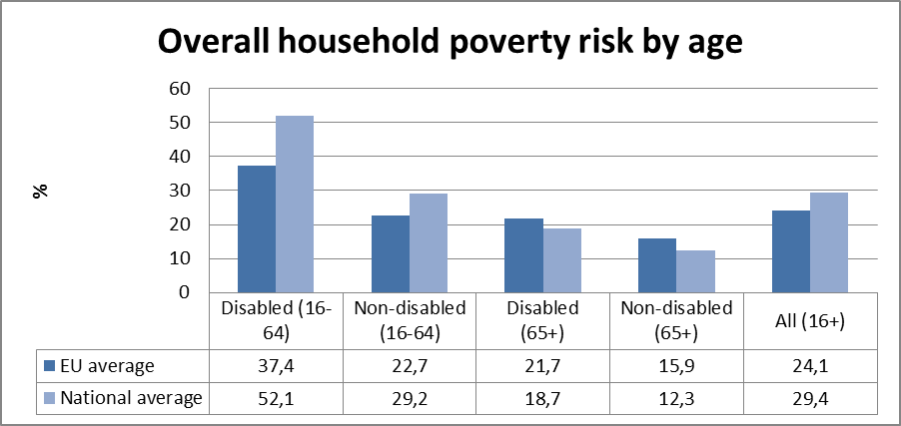
Source: EUSILC UDB 2012 – version 2 of August 2014

Table 18: Three-year trend in overall household risk of poverty and exclusion (EU-SILC 2012)
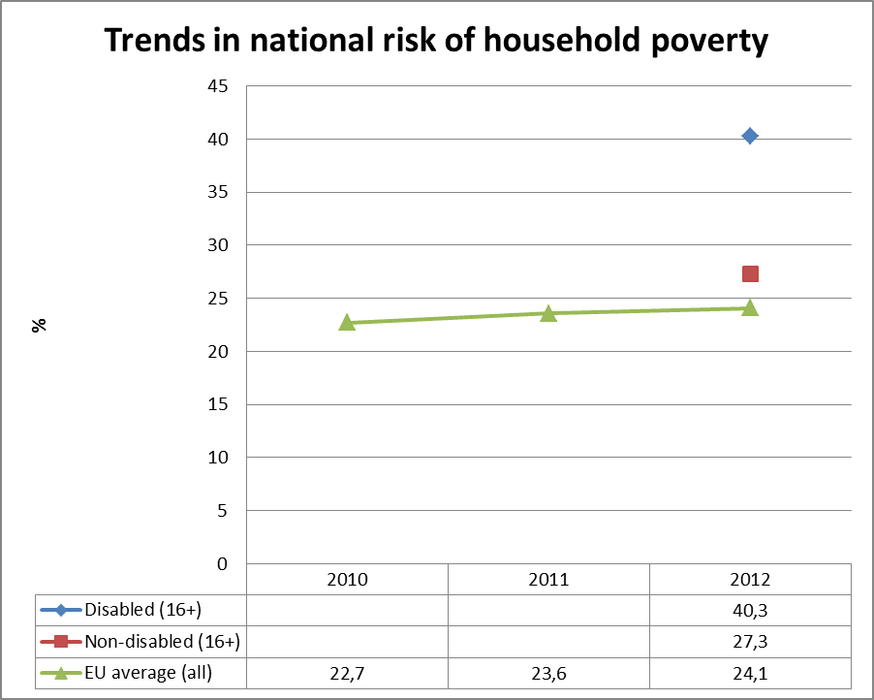
Source: EUSILC UDB 2012 – version 2 of August 2014 (and previous UDB)

There is some missing data for Ireland in the EU-SILC series.
Alternative data on disability and poverty risks from national sources:
The Central Statistics Office has some statistics on poverty and persons with disabilities in their 2014 report on 2012 Survey on Income and Living Conditions.In that report it states that the at risk poverty rate for people age 16 years and older, “not at work due to illness and disability” was 30.3% in 2012. The consistent poverty rate for the same group of people was 17.6% in 2012. The same report also states that the median real household disposable income for persons who are “not at work due to illness or disability” decreased by 10.2% in 2011-2012 from 2010-2011.

As reported in national newspapers Dr. John Cullinan of NUI Galway carried out a study (not yet available online) that found the direct costs of disability has a significant negative impact on the living standards of people with disabilities and their families.

Social Inclusion
The National Physical and Sensory Disability Database Committee Annual Report contains several measures on barriers to participation faced by people with physical and sensory disabilities. 59.3% of people with sensory and physical disabilities reported restrictions on participating in socialising, 57.8% reported barriers to shopping and 55.4% reported barriers to sports of physical recreation.

Description of the situation and trends in relation to each target area

Employment

Situation
We are awaiting the final comprehensive employment strategy for people with disabilities, which is set to be published at the end of 2014. Although the standardised unemployment rate for Ireland was 11.1% in September of 2014, which is down from the previous September it is not clear if the drop in unemployment is impacting people with disabilities. The June 2014 report of the NDA’s Your Voice Your Choice survey found that participants believed that “employer assumptions make it less likely that a person with a disability will get a job.”

Trends
The Annual Report of the National Intellectual Disabilities Database Committee reported an increase in open employment, and supported employment available to people with intellectual disabilities through day services between 1996 and 2013.

Education

Situation
The finalisation of standards for the New Directions plan may help increase participation of students with disabilities in tertiary education, especially students with intellectual disabilities. As highlighted in an Irish Times articles students with intellectual disabilities often have to bear the full cost of courses at third level education institutions while they would not be required to pay for further education conducted through service providers or training centres.

Trends
AHEAD found that while overall the number of students with disabilities in higher education has increased the number of students with visual impairments has decreased over the past two years. The same report also found that students with disabilities seem to be entering certain fields more than others, which may indicate a limitation on students with disabilities choice of course.

On a more positive note 83% if disability/access staff said that in the last three years “they have seen an improvement in the willingness of academic staff to incorporate inclusive teaching methods in their course delivery.”

Poverty and social inclusion

Situation
As noted above, since 2008 there have been cuts in supports and services for people with disabilities. The newest budget does not continue these cuts but nor does it take any measure to reverse the losses of the past six years. The Your Voice, Your Choice survey of people with disabilities, their family members and carers found that survey participants believed that the recent cutbacks negatively impacted their ability to participate in social and cultural life.

Trends
The consistent rate of poverty for people with disabilities grew between 2011 from 6.9% to 10.8% in 2012 according the Social Inclusion Monitor 2012 that was published in 2014.

As highlighted in the most recent National Social Report a recent study found that social transfer mechanisms have been effective in lifting people out of at-risk poverty with an increase in poverty reduction from 2004 to 2011. The report, however, did not mention how the social transfers have specifically impacted people with disabilities. Given the above data it is possible that these gains in reducing at-risk-poverty are not extended to people with disabilities in Ireland.

Assessment of policies in place to meet the relevant headline targets

Employment

The Department for Jobs, Enterprise and Innovation committed to publishing a comprehensive employment strategy for people with disabilities and ran a programme of activities to promote employability of excluded groups such as people with disabilities. However, as of this report no comprehensive employment strategy has been published.

In 2013 a new Further Education and Training Authority was established under the name SOLAS. The 2014 Further Education and Training Services Plan includes a specialist training programme available in five locations for persons with disabilities. Although it is important that the Plan acknowledges the sometimes different needs further education and training needs of persons with disabilities, the complete separation of the training of people with disabilities from people without disabilities under the Plan may discourage full inclusion in the community and not be in line with the CRPD.

Education

The main education act for students with disabilities in primary and secondary education, is the Education for Persons with Special Educational Needs Act (2004) but key portions of the act (e.g. Integrated Education Plans) remain unfunded. As long as this act remains unfunded there are limitations on the access students with disabilities in Ireland to both remain in school and receive the supports necessary that would enable to continue onto third level institutions.

In February 2014, The Hub, a new initiative for young adults with Autism or complex needs was launched in Drogheda. The initiative will provide community and activity support and is a partnership between Praxis Care, HSE, Louth Disability Service, the Genio Trust, Autism Support Louth & Meath and the ABACAS School for Children with Autism. Although promising, this is only a local service so it may not have huge impact on national shortages of placements for school leavers with intellectual disabilities unless it is replicated nationwide.

Poverty and social inclusion

Ireland is nearing the end of its National Action Plan for Social Inclusion 2007-2016. However the most recent report on Social Inclusion made no mentions of any on-going efforts of measures to address social exclusion issues faced by people with disabilities. The most recent Social Inclusion Monitor, which looks at data up to 2012, found that poverty was increasing for people with disabilities. Although the economy has improved in Ireland since 2012 the lack of disability specific or targeted programmes to lift people with disabilities out of poverty may suggest that the improving economy may not affect the poverty rates of persons with disabilities.

The National Reform Programme (NRP) noted that 18% of jobless households have adults with a disability and pledge to undertake further research to inform policy development in this area. The NRP also noted that people with disabilities are the furthest from the labour market. The NRP, however, does not point to any concrete actions, beyond further research, that will be taken to combat poverty of people with disabilities aside from brief mentions of a focus on disability in the Government’s Action Plan for Jobs 2014.

Synergies between developments in the different areas

In 2012 the HSE published New Directions Personal Support Services for Adults with Disabilities. The report sets out a shift in service provision for adults with disabilities away from segregated services to individualised community based supports. This has potential beneficial implications for social inclusion, employment and education. The New Directions Plan, however, has not yet been implemented as Draft Interim Standards are not yet published and were open for public consultation until the 17th of October 2014.

Follow-up of the disability perspective in the European semester

Progress on disability issues in the Country Specific Recommendations (CSRs)

None of the Country Specific Recommendations for Ireland addressed disability.

Table 19: Policy measures related to achieving Recommendation #
Policy Measure
Exact date of adoption
Budget allocation
Stage of implementation
Is an independent evaluation planned?
Assessment of impacts in relation to the CSRs
Ambition sufficient to meet CSRs?
Credibility?

Other CSRs (not disability-specific) with a potential disability perspective/angle

Recommendation 2 calls for the advancing “the reform of the healthcare sector initiated under the Future Health strategic framework to increase cost-effectiveness.” This has the potential of harming people with disabilities.
For example, in 2011 the medical card scheme was centralised in 2011 and in 2012 there was a proposed review of the eligibility of cardholders. The 2013 National Service Plan proposed a reduction of 40,000 medical cards. The 2014 National Service Plan proposed a review of the eligibility of one million card holders during 2014 with the proposed savings resulting from this review and other measures related to medical cards totalling €113 million. The Disability Federation of Ireland raised concerns over the review and how it may negatively impact people with disabilities in Ireland. Down Syndrome Ireland claimed that 50% of children with Down syndrome who were holders of discretionary medical cards had their cards revoked or were in danger of having their cards revoked. In response to widespread public outcry the review of cards was halted and many discretionary cards that were taken away were returned. This example highlights how cost effectiveness in the healthcare sector may negatively impact people with disabilities in Ireland.

Recommendation 3 asks Ireland to “pursue further improvements in active labour market policies, with a particular focus on the long term unemployed, the low-skilled and, in line with the objectives of a youth guarantee, young people.” This recommendation has the potential of improving employment of people with disabilities who are disproportionately represented in the long term unemployed. Ireland, must however, identify the different employment needs of people with disabilities and the different barriers they face while at the same time not segregating services between people with and people without disabilities (see analysis of FET plan).

Assessment of disability relevant issues in the Staff Working Document (SWD)

The Commission Staff Working Document of 2014 notes the important gains that Ireland has made economically and its completion of the EU-IMF financial assistance programme. The document notes that despite the gains made by Ireland there is still concerns to be addressed related to fiscal consolidation and financial/structural reforms. The SWD also points out the continuing challenge of long term and youth unemployment in Ireland. In 2013 long-term unemployment represented over 61% of overall unemployment. Youth unemployment is described as severe in the SWD with those with relatively low education particularly hard hit by unemployment. In response to youth unemployment Ireland produced an implementation plan of the EU Council Recommendation for a Youth Guarantee that will begin in 2014. It is important to note that the Pathways to Work Plan has no targeted measures to address unemployment among young people with disabilities.

Assessment of the structural funds 2007-2013 / ESIF 2014-2020 or other relevant funds

Use of funds in relation to disability challenges

In the National Development Plan for Ireland 2007-2013 executive summary there are a few mentions of disability. The plan states that €19 billion will used under the Social Inclusion priority over the course of the Plan period to “support the provision of programmes and services for people with disabilities.” The Plan also set the goal of raising the employment rate of people with disabilities to 45% from 37%.

The 2007-20013 Human Capital Investment Operational Programme stated that ESF funds would be used to establish a needs assessment service for students with a disability.

The plan also stated that under Priority 2 an area of investment that would be supported is the implementation of the sectoral plans under the Disability Act 2005 which would encourage mainstreaming of services for people with disabilities. Targeted employment training for people with disabilities and support for the Student Access Fund were also included as examples of Priority 2 investments.

There is also an activity implementation plan for a Disability Activation Project which has the objective of addressing the barriers to employment experienced by people with disabilities in Ireland.

In 2013 none of the listed beneficiaries of ESF funds under in the Human Capital Investment Operational Programme were DPOs.

Preparations for ESIF 2014-2020

Ireland has produced a draft Programme for Employability Inclusion and Learning 2014-2020. The Disability Federation of Ireland was a partner involved in the preparation of this draft.
Post Secondary and Tertiary Education
The report notes that although inclusion of students with disabilities in higher education has increased the numbers are not proportional to their representation in society at large and as a result there are new targets being set to increase their representation as a part of work on a third national access plan. As a part of Priority 3 (Investing in Education, Training and Life Long Learning with a view to upskilling and reskilling the labour force) the programme mentions the Fund for Students with Disabilities which funds tailored accommodation and services to support students with disabilities achieve tertiary and post secondary education. €11.2 million of ESF funds investment strategy and operational programme are earmarked to achieve the objective of enabling “disadvantaged and disabled students to access and continue in higher education.”

Employment
People on disability related benefits were also noted as an at risk population for social exclusion connected to long-term unemployment. The report then highlights programs such as JobsBridge and the Intreo data system as programmes they are using to address social exclusion through long-term employment for all affected groups. JobsBridge, however, is not available to people who receive the blind pension. DFI criticised the Intreo system because it focuses on people on the live register which will likely disadvantage and exclude many people with disabilities in Ireland.

The plan also contemplates a “people with disabilities project” to promote social inclusion and combating discrimination in the labour market.

I would just point out that some of the language used in the draft programme is a bit out-dated and refers to people with disabilities as “the disabled” or use disabled as a prefacing adjective

Recommendations

First we would recommend that Ireland ratify the CRPD as soon as the legal capacity legislation is passed, which is expected to happen early in 2015.

Second we would recommend full implementation of the EPSEN act which would give students with disabilities the support they need to succeed in school and thus enable them to be better prepared for tertiary education or employment.

Third we would recommend that Ireland better utilize the twin track approach in addressing disability. Many of the departmental plans for employment, poverty and education do not mention disability or mention it only in passing by referencing the National Disability Strategy. Furthermore Ireland is still using a segregated approach to deliver services to people with disabilities with the 2014 Specialist Training Programme in the Further Education and Training Plan as just one Example.

Fourth as Ireland continues to rebuild its economy and implement the country specific recommendations that very much promote efficiency and reform of social institutions we would caution that such efficiency minded reforms take into consideration the rights and needs of people with disabilities.

Overall there must be much better data collection on education, employment, poverty and social inclusion that includes disaggregation of data based on disability.

http://ec.europa.eu/europe2020/pdf/targets_en.pdf.
National Disability Strategy Implementation Group, National Disability Strategy Implementation Plan 2013-2015, (23 July 2013) 25. < http://www.justice.ie/en/JELR/Pages/PB13000321 > (last accessed 17 October 2014).
Higher Education Authority, Consultation Paper- Towards the development of a New National Plan for Equity of Access to Higher Education, (20 August 2014) 22. < http://www.hea.ie/node/1292 > (last accessed 16 October 2014).
Higher Education Authority, Consultation Paper- Towards the development of a New National Plan for Equity of Access to Higher Education, (20 August 2014) 23. < http://www.hea.ie/node/1292 > (last accessed 16 October 2014).
National Disability Strategy Implementation Group, National Disability Strategy Implementation Plan 2013-2015, (23 July 2013) 7. < http://www.justice.ie/en/JELR/Pages/PB13000321 > (last accessed 17 October 2014).
EUSILC UDB 2012 – version 2 of August 2014.
The SILC survey questions are contained in the Minimum European Health Module (MEHM) http://epp.eurostat.ec.europa.eu/statistics_explained/index.php/Glossary:Minimum_European_Health_Module_(MEHM).
The methodology is further explained in the annual statistical reports of ANED, available at http://www.disability-europe.net/theme/statistical-indicators.
National Disability Strategy Implementation Group, National Disability Strategy Implementation Plan 2013-2015, (23 July 2013) 25. http://www.justice.ie/en/JELR/Pages/PB13000321 (last accessed 17 October 2014).
Anne Marie Carew and Anne Doyle, Annual Report of the National Physical and Sensory Disability Database Committee 2013, HRB Statistics Series 23, (2013) 55. http://www.hrb.ie/uploads/tx_hrbpublications/NPSDD_Committee_Annual_Report_2013-Web.pdf (accessed last 27 October 2014).
Caraíosa Kelly and Anne O’Donohoe, Annual Report of the National Intellectual Disability Database Committee 2013, HRB Statistics Series 24, (2013) 24.
Spinal Injuries Ireland, Special Edition Spinal News, 7 (October 2014) http://issuu.com/terfitz/docs/spinal_news_research_report_edition/0 (accessed last 24 October 2014).
Anne Marie Carew and Anne Doyle, Annual Report of the National Physical and Sensory Disability Database Committee 2013, HRB Statistics Series 23, (2013) 44. http://www.hrb.ie/uploads/tx_hrbpublications/NPSDD_Committee_Annual_Report_2013-Web.pdf(accessed last 27 October 2014).
For the LFS AHM data see, Early school leavers http://appsso.eurostat.ec.europa.eu/nui/show.do?dataset=hlth_de010&lang=en and tertiary educational attainment http://appsso.eurostat.ec.europa.eu/nui/show.do?dataset=hlth_de020&lang=en.
Deputy Finian McGrath, Dáil Debates Volume 772, column Nos.1 10 July 2012.
Disabled school-leavers hit by lack of training opportunities, Irish Independent, (08 October 2013). http://www.independent.ie/lifestyle/health/disabled-schoolleavers-hit-by-lack-of-training-opportunities-29639381.html(accessed 28 October 2014).
Disabled school-leavers hit by lack of training opportunities, Irish Independent, (08 October 2013).http://www.independent.ie/lifestyle/health/disabled-schoolleavers-hit-by-lack-of-training-opportunities-29639381.html(accessed 28 October 2014).
Higher Education Authority, Key Facts & Figures Higher Education 2012/2013, (April 2014) 7 http://hea.ie/sites/default/files/key_facts_and_figures_2012-13.pdf (last accessed 17 October 2014).
Association for High Education Access & Disability (AHEAD), Numbers of Students with Disabilities Studying in Higher Education in Ireland 2012/2013, AHEAD Educational Press (December 2013) 45. http://www.ahead.ie/userfiles/files/shop/free/PARTICIPATION%20RATES%20REPORT%202012-13.pdf(accessed last 27 October 2014).
Central Statistics Office, Survey on Income and Living Conditions (SILC) 2012), 16 April 2014, http://www.cso.ie/en/media/csoie/releasespublications/documents/silc/2012/silc_2012.pdf (accessed last 24 October 2014).
Id. at 16.
Id.
Geraldine Gittens, People with disability ‘twice as likely to experience poverty’ –charity, Irish Independent (24 September 2013). http://www.independent.ie/irish-news/news/people-with-disability-twice-as-likely-to-experience-poverty-charity-30612917.html (accessed last 24 October 2014).
Anne Marie Carew and Anne Doyle, Annual Report of the National Physical and Sensory Disability Database Committee 2013, HRB Statistics Series 23, (2013) 16. http://www.hrb.ie/uploads/tx_hrbpublications/NPSDD_Committee_Annual_Report_2013-Web.pdf (accessed last 27 October 2014).
CSO, CSO Statistical Release, (o1 October 2014). http://www.cso.ie/en/releasesandpublications/er/lr/liveregisterseptember2014/#.VE6uqousVPw (accessed last 27 October 2014).
National Disability Authority, Your Voice, Your Choice 2013 Report, (June 2014) 8.http://www.nda.ie/CntMgmtNew.nsf/DCC524B4546ADB3080256C700071B049/4A04714B2B612D9B80257D070037B12E?OpenDocument (accessed last 27 October 2014).
Caraíosa Kelly and Anne O’Donohoe, Annual Report of the National Intellectual Disability Database Committee 2013, HRB Statistics Series 24, (2013) 24. http://www.hrb.ie/uploads/tx_hrbpublications/NIDD_Committee_Annual_Report_2013-Web.pdf (accessed last 27 October 2014).
Joe Humphreys, Students with intellectual disability lack further options, Irish Times, (13 August 2014).http://www.irishtimes.com/news/education/students-with-intellectual-disability-lack-further-options-1.1895009?page=2 (accessed last 27 October 2014).
AHEAD, Students with Disabilities Studying in Higher Education in Ireland 2013/2013, AHEAD Educational Press (December 2013) 2. http://www.ahead.ie/userfiles/files/shop/free/PARTICIPATION%20RATES%20REPORT%202012-13.pdf (accessed last 27 October 2014).
Id.
AHEAD, Students with Disabilities Studying in Higher Education in Ireland 2013/2013, AHEAD Educational Press (December 2013) 46. < http://www.ahead.ie/userfiles/files/shop/free/PARTICIPATION%20RATES%20REPORT%202012-13.pdf(accessed last 27 October 2014).
National Disability Authority, Your Voice, Your Choice 2013 Report, (June 2014) 8 http://nda.ie/Publications/Others/
Department of Social Protection, Social Inclusion Monitor 2012, National Social Target for Poverty Reduction, (September 2014) 30. http://www.socialinclusion.ie/documents/SIM2012_003.pdf (accessed last 27 October 2014).
Social Inclusion, National Social Report 2014, (April 2014) 8. http://www.socialinclusion.ie/IrelandsNationalSocialReport2014.html (accessed last 27 October 2014).
Department for Jobs, Enterprise & Innovation, Action Plan for Jobs 2014, (February 2014). http://www.djei.ie/publications/2014APJ.pdf (accessed last 27 October 2014).
SOLAS, The 2014 Further Education and Training Services Plan, FET Operational Planning & Stakeholder Engagement Unit, (March 2014) 99. http://www.solas.ie/docs/FETServicesPlan.pdf (accessed last 27 October 2014).
HSE, New initiative for young adults with Autism or Complex Needs Launched by Minister Lynch, (27 February 2014). http://www.hse.ie/eng/services/news/newsarchive/2014archive/feb14/New_initiative_for_young_adults_with_Autism_or_Complex_Needs_Launched_by_Minister_Lynch.html (accessed last 28 October 2014).
National Reform Programme Ireland (April 2014), 50 http://ec.europa.eu/europe2020/pdf/csr2014/nrp2014_ireland_en.pdf (accessed last27 October 2014).
Id. at 51.
Department for Jobs, Enterprise & Innovation, Action Plan for Jobs 2014, (February 2014). http://www.djei.ie/publications/2014APJ.pdf (accessed last 27 October 2014).
HSE, New Directions-Review of HSE Day Services and Implementation Plan 2012-2016, Working Group Report (February 2012). http://www.hse.ie/eng/services/publications/Disability/newdirections2012.pdf (accessed last 27 October 2014).
HSE, Disability Services, New Directions, http://www.hse.ie/newdirections/ (accessed last 27 October 2014).
Public Accounts Committee, Report on the Review of Medical Card Eligibility, House of the Oireachtas, (October 2014) 6. http://www.oireachtas.ie/parliament/media/committees/pac/cagreports/Report-on-the-review-of-medical-card-eligibility-2014.pdf (accessed last 28 October 2014).
HSE, National Service Plan 2013, 15, http://www.hse.ie/eng/services/Publications/corporate/NSP2013.pdf (last accessed 28 October 2014).
HSE, National Service Plan 2014, 39. http://www.hse.ie/eng/services/Publications/corporate/serviceplan2014/nationalserviceplan2014.pdf (accessed last 28 October 2014).
Disability Federation of Ireland, Disability Federation of Ireland Raises Concerns Over Medical Card Review, Dublin (18 October 2013).
Down Syndrome Ireland, Down Syndrome Ireland Medical Card Statement, (15 May 2014). http://www.downsyndrome.ie/wp-content/uploads/2013/12/Medical-Card-Statement-DSI.pdf (accessed last 28 October 2014).
Paul Cullen, Government’s U-turn on medical cards widely welcomed, Irish Times (18 June 2014). http://www.irishtimes.com/news/health/government-s-u-turn-on-medical-cards-widely-welcomed-1.1835941 (accessed last 28 October 2014).
SWD(2014) 408 final.
Id. at 3.
Id at 19.
Id.
Id. at 20.
Department of Social Welfare, Pathways to Work-The implementation of the EU Council Recommendation for a Youth Guarantee Ireland, (January 2014). http://www.welfare.ie/en/downloads/youth-guarantee-implementation-plan.pdf (accessed last 27 October 2014).
Ireland National Development Plan 2007-201: Transforming Ireland A Better Quality of Life for All-Executive Summary, 17 (January 2007).
Ireland National Development Plan 2007-201: Transforming Ireland A Better Quality of Life for All-Executive Summary, 22 (January 2007).
Department of Education and Skills, Human Capital Investment Operational Programme 2007-2013, Ireland’s EU Structural Funds Programmes 2007-2013, 66 (February 2012).http://www.esf.ie/en/hci-overview.aspx (accessed last 20 November 2014).
Id. at 70.
Id. at 70-71
The European Social Fund in Ireland, Human Capital Investment Operational Programme, Implementation Programming, Disability Activation Project, http://www.esf.ie/en/hci-implementation-programming.aspx (accessed last 20 November 2014).
The European Social Fund in Ireland, Human Capital Investment Operational Programme, List of Beneficiaries 2013, http://www.esf.ie/en/hci-overview.aspx (accessed last 20 November 2014).
Department of Education and Skills and Irelands EU Structural and Investment Funds Programmes 2014-2020, DRAFT Programme for Employability, Inclusion and Learning 2014-202 Supported by the European Social Fund,(July 2014). http://www.esf.ie/en/about_esfprogramme_2014_2020.aspx (accessed last 20 November 2014).
Id. at 101.
Id. at 13.
Id at 27.
Id. at 34.
Id. at 17.
DRAFT Programme for Employability, Inclusion and Learning 2014-2012 at 17.
JobsBridge, General Guidelines, Information for Interns-Am I Eligible, http://www.jobbridge.ie/InternEligible.aspx. (accessed last 20 November 2014).
Disability Federation of Ireland, Submission to the Department of Social Protection-Recommendations for Budget 2014 (June 2013).
DRAFT Programme for Employability, Inclusion and Learning 2014-2012 at 50.
DRAFT Programme for Employability, Inclusion and Learning 2014-202 at 19, 27 29, 34, 37, 47, and 56.

